Egyptian Influences and Symbols in D.C.

Naomi Berkins

Dan Brown's upcoming novel, The Solomon Key, has been far too long unpublished, and it probably will be a while yet until it comes out. The fact that the book has not come out has not prevented predictions about what the plot will be and what it will involve. One such topic of interest is what symbols might be included in the process of Langdon's quest. In his previous novels Dan Brown used symbols like roses and triangles, but what symbols could he find hidden within the United States? The answer to that question is many, more than one probably even realizes, from astrology signs to even Greek and Egyptian influences. One of the most fascinating connections is the Egyptian influence on our country and the founding fathers and its symbols found throughout the capital. The ancient Egyptians are one of the first advanced civilizations and its no wonder that the founding fathers looked to them for inspiration. From Egypt's civilization to their hieroglyphics, Egypt has influenced America in many aspects. Some of the capitals buildings are clearly influenced by Egypt, for example the Washington Memorial and the Scottish Rite House of Temple, and then there are some that are not so recognizably influenced by Egyptians, like the pentagon and the IRS building. Even on the dollar bill can you find Egyptian influence in the unfinished pyramid. Though the ancient Egyptian civilization is long gone, its influence is still felt, and in Washington D.C. you can find that this is very true. Because they were such a big influence on the founding of our country, it is very likely that Egyptian symbols will be a reoccurring theme in The Solomon Key.
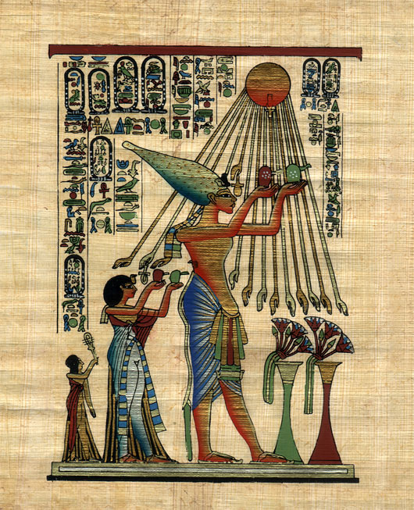
In Manly P. Hall's book, The Secret Destiny of America, he writes about how our democratic society is in part based on the ancient Egyptian pharaoh, Akhnaton. It is said the Akhnaton was the first democrat in the world, and it is also said that "one might compare the modern day United States to the Egypt of that day" (Goodwin and Shennefield). He started his own religion in which there was only one God, Aton. At that time most religions worshipped a multitude of Gods. Akhnaton's religion viewed all people equally, just as our country does, "all men are created equal" (Declaration of Independence). It is clear from Akhnaton's reign as Pharaoh of Egypt that America's founding fathers got some of the basis of the Declaration of Independence and the Constitution, though it might not be directly taken from them. The ancient Greek philosophers like Plato and Socrates influenced the Founding Fathers and the Egyptian influenced them. Another similarity between our country and Akhnaton's views was that he was tolerant of all religions, just as our Constitution states: "congress shall make no law respecting an establishment of religion, or prohibiting the free exercise thereof." Akhnaton was the only Pharaoh to have had these sorts of ideas, and after him, it would take many more years until this kind of thinking was brought up, and it even longer before it was accepted into everyday life.
In the planning of Washington D.C. you can also find connections to what Egyptians considered important and their society. Though intentional or not the "alignment along Pennsylvania Avenue, between the White House and the site of the Capitol building (Jenkins Hill), with the site of the rising of the brightest star in the sky, Sirius" (Taylor 83). Sirius symbolized the New Year to the Egyptians and it also has close ties to the goddess Isis. Though you can say that this might all just be coincidence, once you start looking into all the “coincidences” around Washington D.C., you just can't call them coincidences anymore. For example, in David Ovason’s book, The Secret Architecture of Our Nation’s Capitol, he writes of how many of the buildings were built during certain astrologically significant times. The Washington Monument for example was built when not one, but three planets were in Virgo, the Moon, Mars, and Uranus, yet another tie to the Sacred Feminine. In addition at the same time, “the most important star in the constellation” (Ovason 131) was rising, Spica.
Many monuments and buildings found in Washington D.C. have Egyptian influences, and it is more than likely not many people recognize this fact. The Washington Monument is probably one the most recognizable monuments that has Egyptian ties. The shape of the monument is an obelisk and this is very Egyptian. An obelisk basically signifies power, continuity, immortality and resurrection. You can find obelisks all throughout Egypt. They are usually found pairs in front of temples, and are most commonly found with hieroglyphics written on it. The obelisk was a form of protection to the temple it was in front of and it also symbolized the stability of their sun god Ra (Lunghi). Freemasons base the construction of their buildings on symbolism and it is quite possible that the builders of the Washington Monument wanted to portray Washington in such a Godly way. Washington was the first president of the Untied States, a Freemason, and was a general during the fight for Independence. To the American people of that time, he was held in very high esteem and because of this he brought stability to a once unstable country and he will forever be considered immortal in America.
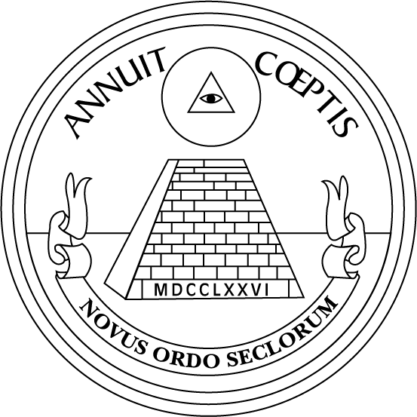
Another such building that has Egyptian ties is the Scottish Rite House of Temple. Ovason states in his book that it is "the only architectural pyramid in Washington D.C., which seems to reflect the seal pyramid is distinctly Masonic" (Ovason 221). The pyramid on the great seal of the United States clearly has Egyptian backgrounds, so it is not surprising if the Scottish Rite House of Temple has Egyptian influences as well. The pyramid, for the Egyptian, was a way to get closer to God and truth, and Freemasons were all about finding truth and knowledge. The Great Seal as we now see it on the back of our dollar bill was not always there. Not until Franklin D. Roosevelt became president did the reverse side of the Great Seal, the unfinished pyramid, start to be used though it was designed in 1782. The Scottish Rite House of Temple was also built during a significant celestial time, according to Ovason “the Moon and Venus [were] together (conjunct) in Virgo” (Ovason 223). This is yet another tie to the Sacred Feminine. Many building built in Washington D.C. were somehow connected to the Sacred Feminine, whether through when it was built, and what plant and stars were in the sky at the moment, to what is seen outside or on that particular building.
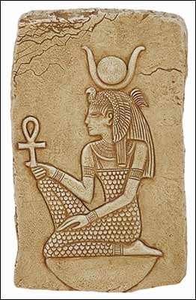
One of the many reoccurring themes concerning Freemasons and the founding of our capital is the topic of the Sacred Feminine. The Sacred Feminine can be found in much of Freemasonry iconography as well as in the art and architecture of the capital. The Scared Feminine is basically the representation of the mother symbolized through images connected with fertility and reproduction. One of the earliest representations of the Scared Feminine is the Egyptian goddess Isis, the most powerful of all the gods. The sacred feminine is caring, wise, and the mother of all things. She is built into the very foundations of our capital, "Ovason sees the capital of the United States as being founded by Masons, and devoted to the goddess principle - be it Isis, Demeter, or the Virgin" (Taylor 79). One can find statues that depict a representation of the sacred feminine all over, such as the Monument to a Master Mason. Not only that, but when many buildings were being built, or when there corner or foundation stones were put in place, there is very often a Scared Feminine tie to it, or as Ovason puts it they were built in under the influence of Virgo. As already previously stated, there are just too many occurrences in which buildings were constructed during an important lunar time. Because of this connection between when these buildings were constructed and where stars and planets were at that time, the Founding Fathers could not have disregarded that their being built had a connection to Virgo, or any other sort of feminine figure.
The Egyptians have had a profound influence on so many modern day cultures, including the United States. They have influenced the Founding Fathers by means of their views on freedom to religion and they have influenced the some of the architecture found in Washington D.C. You can see examples of this in the Washington Monument and the Scottish Rite House of Temple, a Masonic House. No matter where you go you can find some evidence of the Egyptian influence. Whether or not Dan Brown will include the Egyptians in his book is hard to say, but with how much they influenced the planning and construction of Washington D.C. it shouldn’t be a surprise if they do come up in some manner.

Works Consulted

Goodwin, Gary D. and Shennefield, Marianne. One Great Round The Story of Man's Search For Meaning: Part One The Akhnaton Frequency. 14 November, 2007. http://owl.english.purdue.edu/owl/resource/557/09/

Hall, Manly P. The Secret Destiny of America. Los Angeles: The Philosophical Research Society, 1991.

Hall, Manly P. The Secret Teachings of All Ages. New York: Tarcher/Penguin, 2003.

Ovason, David. The Secret Architecture of Our Nation’s Capital. Great Britain: Perennial, 2002.

Taylor, Greg. The Guide to Dan Brown’s The Solomon Key. California: DeVorss & Company, 2005.

About.com: Alternative Religions. A New Order of Ages: The Masonic Enlightenment and the Symbols of America. 14 November, 2007. http://altreligion.about.com/library/weekly/aa111604a.htm

