Leon Templo
and
The New Solomon Temple

Olivia Cooney

The Solomon Temple was the first Jewish Temple in Jerusalem, and there is a lot of meaningful history surrounding it. It is believed to have been built on top of the Dome of the Rock, the spot where God tested Abraham, and asked him to sacrifice his son.
And it came to pass after these things, that God did test Abraham and said unto him… Take now thy son, thine only son Isaac, whom thou lovest, and get thee into the land of Moriah; and offer him there for a burnt offering upon one of the mountains which I will tell thee of. And Abraham … went unto the place of which God had told him… And they came to the place which God had told him of; and Abraham built an altar there… and bound Isaac his son, and laid him on the altar upon the wood. And Abraham stretched forth his hand, and took the knife to slay his son. (Genesis: 22).
It continues to hold a deep religious connection and meaning for millions of Jews throughout the world. The temple was completed some time in the tenth century BC. It became a place of frequent religious ritual, which drew people to the city of Jerusalem. After the Babylonians destroyed it in 586 BC, the Jews were exiled; this was the first of many recorded persecutions of Jewish people throughout history. Clearly the Solomon Temple holds a well deserved important place in history. Despite this, not many people know much about the temple past its Jewish roots. What few do know is that after the temple was destroyed, a man named Jacob Judah Leon, also known as Leon Templo, made plans to rebuild the temple. He did not plan to rebuild it on the exact location as it was located before, because sometime in the late 600s AD, the Dome of the Rock was built where Solomon’s Temple had stood. Even today, it is the most famous landmark in Jerusalem. No proposal for a second Solomon’s Temple had been produced before Leon’s because the Dome of the Rock, or the Temple Mount as it is referred to in Judaism, had replaced Solomon’s Temple in terms of significance in the history of Judaism. Leon was interested in rebuilding it because of the Masonic ties it held. He had a complete and detailed design drawn up, accompanied by pamphlets which included a portrait of him that became famous throughout Europe, and he even wrote a book in 1642 to accompany his temple, explaining his designs. This book was so well received and widely read that it was then translated into several other languages. (www.wikipedia.com).

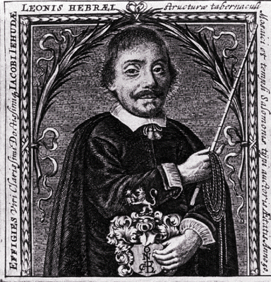
The portrait of Leon Templo which became famous
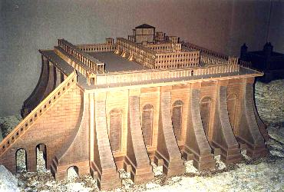
A to scale model of Leon Templo’s design for the second Solomon’s Temple

Jacob Judah Leon’s connection to the Solomon Temple is at the root of his relationship to the Freemasons, who in history have had an undeniable fascination with the Solomon Temple. While it cannot be proved that Leon himself was a freemason, he pops up frequently throughout their history.
Leon was born in 1603 in a Portuguese town somewhere in the proximity of Coimbra. Later in life he came to be known as Leon Templo. In the short version of the summary of his life he is generally described as a hakham (a Hebrew word used to describe people who are wise, skillful, cultured, and learned), a translator of the Psalms, and an expert on heraldry (the practice of designing coats of arms and badges). This last talent is where Leon’s life first became a part of Masonic history. Sometime in the mid to late 1600s, Leon’s work in heraldry impressed Laurence Dermott, the first Grand Secretary of the Grand Lodge of the Ancients, to the extent that Dermott designed the Coat of Arms for his Grand Lodge using one of Leon’s designs as the foundation. The design remained for some two hundred years until in 1813, the two grand lodges of England merged to form the United Grand Lodge. The design is still remnant and has a presence in the coat of arms of the present United Grand Lodge.
Another strong link between Leon and the Freemasons begins in the little city of Livorno, located on the northwestern coast of Italy. Leon’s daughter, Elisabeth, married a Jewish man who was known to be from Livorno. Livorno was host to a large Jewish community and when Freemasonry made its way to Italy sometime in the late 1500s, the city became a place where Masonic activity was frequent and strong. For example, over fifty percent of all freemason lodges in Italy were located in Livorno. The fact that freemasonry became so popular in this rather tiny community is noteworthy, and strongly suggests that there were already Masonic happenings in the city before freemasonry officially arrived in Italy. These happenings imply no more than things such as houses that were built for Freemasons (essentially lodges) and there may have also been some Freemason gatherings. (Freemasonry in Israel 1).
It is important to keep in mind that these are all theories. One can only speculate that freemasonry existed at this time. Freemasonry didn’t officially come into existence sometime around the mid 1700s.
A final correlation between Leon Templo and the freemasons began while Leon was traveling throughout Europe and presenting his proposition for the Second Temple. A Freemason named Christopher Wren (1632- 1723) observed his proposal and told his close friend, and fellow mason, Isaac Newton about it. From then on, Newton too was fascinated by the Temple, and dabbled in drawing his own sketches and plans for the second one.
To understand Leon Templo, Adam Boreel, Isaac Newton, and Christopher Wren’s motivations, it is best to first understand the connection between Freemasonry and the Solomon Temple. It all began when Solomon inherited the throne from King David, his father, and gave the initial order for the beginning of the construction of the Solomon Temple. Hiram, the King of Tyre, had already volunteered to King David to help with the construction of the temple. Hiram had provided a great service to King David during his reign, so some forty years later when it came time to start building the temple, Solomon depended on Hiram to provide him the same service.

7:13 |  | And king Solomon sent and fetched Hiram out of Tyre.
7:14 |  | He was a widow's son of the tribe of Naphtali, and his father was a man of Tyre, a worker in brass: and he was filled with wisdom, and understanding, and cunning to work all works in brass. And he came to king Solomon, and wrought all his work.
7:15 |  | For he cast two pillars of brass,

(Bible)
The connection between the temple and the freemasons becomes clearer when the specific pieces of architecture within the temple are observed. First and foremost were the two giant pillars, each over eight meters tall, that surrounded the main entrance to the temple. They were massive and looming, each weighing over forty tons. The left one was called Boaz, and the right one was called Jachin. Boaz was named after Boaz, the great-grandfather of King David, and the name is supposed to conjure a feeling of strength. The Masons “say of the southern pillar [Boaz] that ‘in it was strength’.” Jachin, the northern pillar was named after the High priest of Jerusalem. This priest advised King Solomon during the building of the Solomon temple. The Masons connect this pillar with stability “and [say] of the…pillar ‘its purpose was to establish’… The two pillars combine to create harmony and stability; for the sacred law of the Most High says ‘In strength will I establish my law in this mine house that it will stand fast forever’.” Each pillar holds a special meaning in the traditions of the Freemasons, and these customs are examined in the initiation of each new Freemason. (Lomas 124-5).
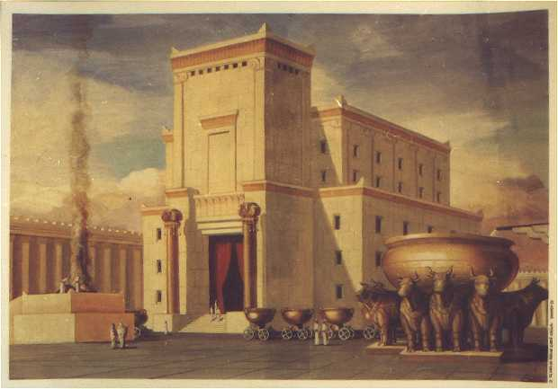
A portrait of the original Solomon’s Temple

These pillars were built by Hiram Abif, the widows’ son. Hiram is another critical player in Freemason history. He was a chief architect in the construction of Solomon’s Temple, and the son of a Widow. Ironically, the masterpiece that he built is where he met his demise. Hiram Abif was murdered by three ruffians who were trying to force the secrets of a master mason out of him. Hiram held the secret of God’s true name, or “The Grand Masonic Word.” Knowing the name of a spirit supposedly gave the secret holder its powers. Hiram promised all the workers who were building the Solomon Temple that he would share this name with them after the completion of the building. This would enable them all to strike out on their own and work as master masons and earn master mason wages. These three ruffians were working on the temple, and did not want to wait until it was complete to have the power. As they attacked Hiram one by one he ran to various places throughout the temple trying to escape, and while he never divulged the secrets, he did meet his end when the third man struck him with a blow to the head.
Today in Masonic culture, Hiram still plays a vital role. As each person goes through the rituals on his journey to obtaining a Master Mason degree, or the Third Degree (which for most is the final degree as well), he or she must re-enact what Hiram Abif went through that day when he was pursued and killed by the ruffians. Another remaining trace of Hiram that can be seen in freemasonry is the phrase that any freemason can cry out and no matter what the situation is, his brother mason will spare him and show mercy. Say, for example, two freemasons are on opposing sides in a battle. If one cries out “Oh Lord, My God, is there no help for the widow’s son?” the other is supposed to spare him. These words are by no means empty; “there are many stories in which combatants on opposite sides in battle set aside their weapons in order to answer this plea. Paul Revere was said to have been spared by a British captain who detained him on the night of his fateful ride, because each recognized certain coded phrases that revealed a fellow Freemason” (Shugarts 22).
It is because the Solomon Temple and freemasonry are so tightly intertwined that many freemasons became very interested in the temple. Two specific examples of these Freemasons are Isaac Newton and his friend Christopher Wren. Christopher Wren was an English knight who was extremely interested in architecture. He is most famous for having built over fifty of the churches in London, as well as a great number of the secular buildings in the city after the Great Fire. Wren was also the master mason of a lodge in London. The combination of his freemason roots and extreme passion for architecture made him the perfect audience for Leon Templo as he traveled throughout Europe giving presentations on his new design for the second Solomon’s Temple. Thus, it should come as no surprise that Christopher Wren was present at Leon Templo’s presentation in London. Wren was very interested in the architectural aspects of the temple. He studied who built and designed the temple, (he focused on Hiram) and used this to try and understand more about the temple and any possible further meanings that the architecture bore. Perhaps he hoped that Leon Templo’s presentation would provide him more insight to the significance behind the architecture and structure design of Solomon’s Temple. He was also probably interested to examine Leon’s take on the second version of the Temple, and discuss the reasons behind his designs.
Several of Christopher Wren’s tracts on architecture… are concerned with ancient buildings, but they show scant regard for… the sacred principles employed by God as designer. Wren is interested in Solomon’s Temple… as he was in a number of ancient structures, but for him its status as architecture is not enhanced by its divine inspiration. Since Solomon… was in correspondence with King Hiram, he argues, what we might discover about the Tyrian style would enrich our knowledge of the Temple. (http://www.mhs.ox.ac.uk/gatt/temple/catalog.asp?CN=60)
In 1675, a summary of Leon’s proposal for the temple was published in English in Amsterdam. Constantijn Huygens, the secretary to the Dutch prince, “provided Leon with a letter of introduction to Christopher Wren, who would be able to judge the models and introduce Leon to the circle of the Royal Society. Whatever the motive for this move, whether connected with mathematical interest in the Temple or with millenarian aspirations that necessitated its reconstruction, they were overtaken by Leon’s death in July 1675” (http://www.mhs.ox.ac.uk/gatt/temple/catalog.asp?CN=60).
A close friend of Wren’s and fraternal brother was Sir Isaac Newton. It is accepted that Newton was not an official Freemason, however he was a member of a semi-Masonic group, the Gentleman’s Club of Spalding, and it has been observed that he shared many of the same views as the Freemasons. Newton too showed a particular interest in the Temple and “later spent time making his own sketches of the floor plan of the Temple” (Shugarts 62). Not only that but he also “ascribed great significance to the configuration and dimensions of Solomon's temple. The dimensions and configuration of the temple he believed to conceal alchemical formulas; and he believed the ancient ceremonies in the temple to have involved alchemical processes” (http://uplink.space.com).
Leon Templo’s thoughts and presentations likely influenced Newton and Wren to strive to learn more about the Solomon Temple. The question is, from where did Leon draw his own inspiration? The answer to this can be found by examining Adam Boreel. Boreel was a close friend of Leon’s and it was he who fed Leon’s interest in the Temple and encouraged him to act on it.
Boreel was a Dutch theologian and Hebrew scholar. He was very interested in Judaism, which is how we came to know and become close with Leon Templo. They did not speak the same languages, and so in order to communicate, Boreel learned Portuguese. After he encouraged Leon to produce his own model of the Solomon Temple, “he elicited his help in producing a punctuated and annotated edition of the Mishna, or Jewish Oral Law” (www.newtonproject.sussex.ac.uk).
Jacob Judah Leon found the idea of designing and rebuilding the Solomon Temple fascinating. There is no doubt that the Solomon Temple has played a role historically in more ways than one. It provided the first safe place for Jews to pray, as well as numerous hidden symbols and meanings for the Freemasons. Surely Dan Brown has thoroughly researched the Solomon Temple, and can incorporate the rich history surrounding it into his next novel. Perhaps, Leon Templo could play a role in one of his conspiracy theories; with the Solomon Temple, the possibilities are endless.
Anonymous. <http://www.freemasons-freemasonry.com/zeldis22.html>.

Anonymous. <http://en.wikipedia.org/wiki/Judah_Leon_Templo>.

Anonymous. <http://64.233.169.104/search?q=cache:2HdvsAYGDnoJ:www.geocities.com/fmisrael//sephardic.html+Jacob+Judah+Leon&hl=en&ct=clnk&cd=21&gl=us>.

Anonymous. <http://64.233.169.104/search?q=cache:XCWifwyCOwsJ:www.nextbook.org/cultural/feature.html%3Fid%3D178+Jacob+Judah+Leon%27s+Solomon+Temple&hl=en&ct=clnk&cd=2&gl=us>.

Anonymous. <http://www.mhs.ox.ac.uk/gatt/temple/catalog.asp?CN=56>.

Anonymous. <http://www.freemasons-freemasonry.com/kst.html>.

Anonymous. <http://www.geocities.com/fmisrael//sephardic.html>.

Anonymous. <http://www.watch.pair.com/symbol.html>.

Anonymous. <http://www.mhs.ox.ac.uk/gatt/temple/catalog.asp?CN=60>.

Anonymous. <http://uplink.space.com>.

Anonymous. <www.newtonproject.sussex.ac.uk>.

Dermott, Laurence. Ahiman Rezon. Abridgement. Philadelphia: Hall and Sellers, 1783.

Lomas, Robert. Turning the Hiram Key. Gloucester: Fair Winds Press, 2005.

Shugarts, David A. Secrets of the Widow’s Son. New York: Sterling Publishing Co., 2005.

Stanford, John. Sacred Architecture; or, The design of Jehovah in building the temple of Solomon.

Templo, Jacob Judah Aryeh Leon. Retrato del Templo de Selomoh

Templo, Jacob Judah Aryeh Leon. Retrato del Templo de Selomoh

